## *Free Account

https://github.com/Filkolev/SoftUni/tree/master/Web%20Fundamentals/Exams/Exam-2014-11-01/03

Create a Web form (HTML5 + CSS3 + images) that looks and behaves like the screenshots below:

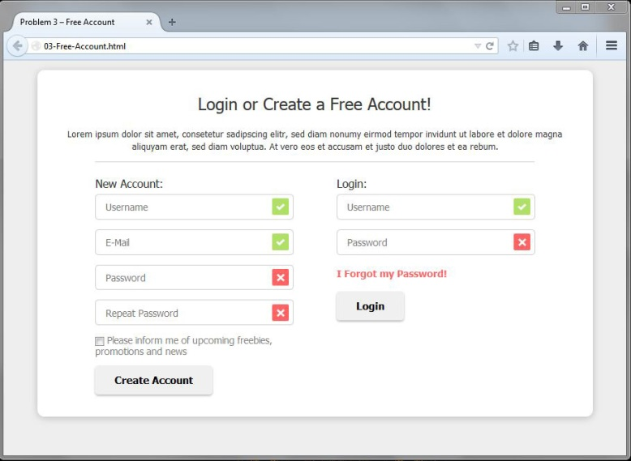 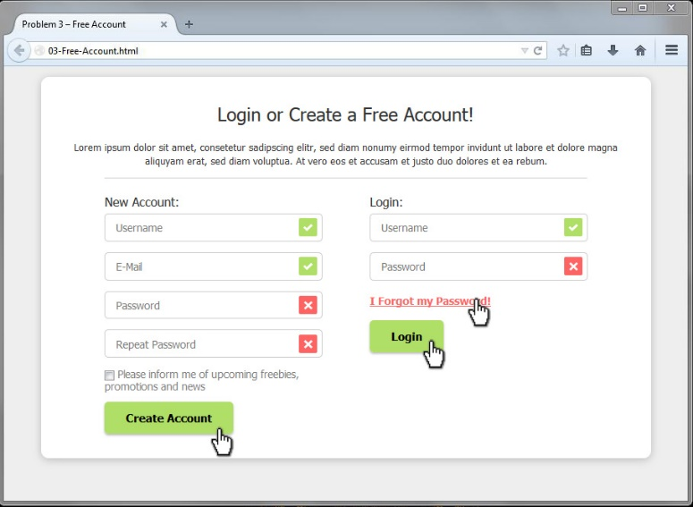

### Input

You are given the above screenshots and all required images.

### Output

The output should be valid HTML5 + CSS3 + images that implement the above Web form.

* You do not need to implement form validation. The images at the end of the fields are static – do not depend on the text inside the field.

### Constraints

* Font: Tahoma, Helvetica, sans-serif.
* Site content: fixed width 800px.
* Heading font-size: 24px.
* Form validation is not required.
* The site should open correctly in Chrome 38.
* Responsive design is not required.
* Pixel-perfect implementation is not required.

<!DOCTYPE html>

<html>

<head>

<meta charset = "UTF-8"/>

<title>Free Account</title>

<link rel="stylesheet" href="style.css"/>

</head>

<body>

<div id="wrapper">

<h2>Login or Create a Free Account!</h2>

<p><h4>Lorem ipsum dolor sit amet, consetetur sadipscing elitr, sed diam nonumy eirmod tempor invidunt ut labore et dolore magna aliquyam erat, sed diam voluptua. At vero eos et accusam et justo duo dolores et ea rebum.</h4></p>

<section id="forms">

<form id="account" method="post" action="#">

<header>New Account</header>

<div class="input">

<input type="text" name="username" placeholder="Username"/>

<input type="email" name="email" placeholder="E-Mail" />

<input type="password" name="password" placeholder="Password" />

<input type="password" name="password-repeat" placeholder="Repeat Password" />

<p><input type="checkbox" name="checkbox" />Please inform me of upcoming freebies, promotions and news</p>

<input type="submit" value="Create Account"/>

</div>

</form>

<form id="login" method="post" action="#">

<header>Login</header>

<div class="input">

<input type="text" name="username" placeholder="Username"/>

<input type="password" name="password" placeholder="Password" />

<p><a href="#">I Forgot my Password!</a></p>

<input type="submit" value="Login" id="left"/>

</div>

</form>

</section>

</div>

</body>

</html>

body {

font-family: Tahoma, Helvetica, sans-serif;

font-size: 13px;

}

#wrapper {

width: 800px;

height: 550px;

margin: 0 auto;

border-radius: 10px;

box-shadow: 0 0 10px 2px #d8d8d8;

padding: 30px;

box-sizing: border-box;

}

h2, h4{

text-align: center;

font-weight: normal;

font-size: 24px;

padding: 10px;

}

h4{

font-size: 1em;

}

section#forms {

width: 90%;

margin: 0 auto;

border-top: 1px solid #cecece;

vertical-align: top;

padding-top: 20px;

}

form {

display: inline-block;

position: relative;

width: 50%;

}

input[type="text"],

input[type="email"],

input[type="password"]

{

width:85%;

border: 1px solid #cecece;

border-radius: 3px;

height: 28px;

margin: 5px 0px;

padding-left: 10px;

}

#account{

float: left;

}

#login div{

text-align: right;

}

#login header,

#login div p{

margin-left: 37px;

text-align: left;

}

#left{

position: relative;

right: 227px;

}

input[type="checkbox"]{

margin-left: -1px;

border-radius: 0px;

}

#account p{

width:80%;

}

input[type="submit"]{

background: #ececec;

border: none;

border-radius: 5px;

font-weight: bold;

height: 35px;

padding: 8px 15px;

box-shadow: 0px 3px 3px #bdbdbd;

}

input[type="submit"]:hover{

cursor: pointer;

background: #afdf67;

}

a{

color:red;

text-decoration: none;

font-weight: bold;

}

a:hover{

color: red;

text-decoration: underline;

}

input[type="text"],

input[type="email"]{

background-image: url('ok.png');

background-repeat: no-repeat;

background-position: 97% 50%;

}

input[type="password"] {

background-image: url('no.png');

background-repeat: no-repeat;

background-position: 97% 50%;

}